Brief

2026 Team: Connor, Justin, Yolanda

Group Folder

Last Year Interview Notes

Problems / Questions:
- Coral restoration cannot currently be scaled proportionally to the consequences of inaction
- Misalignment between public/private sector stakeholders, fragmented and incohesive efforts
- Cost of action vs inaction is not reflected in current financing mechanisms
- Conflicting approaches to replanting (high tech vs simple) → do we prioritize volume or survival rates?
  - Within targeted approaches (prioritizing efficacy), how do we decide which geographic areas to target?
- Conflicting approaches to managing coral more broadly - generally three categories - restoration (replanting), preservation (protect what is left of natural reefs), education (focus on changing public perception of reefs to change correlated human activities)

Active Contacts:
- Coral Restoration Contact List BUAD493

Year 1 Progress:
- BUAD493 Report - survey on state of coral restoration in Indonesia, including barriers/ opportunities to further intervention, stakeholder perspectives, comparative analysis between different financing options, etc
- BUAD494 - Anica Camacho - Designing a Multi-Investor Ecosystem for Coral Restoration
- BUAD494 - Riley Pierce - The Psychological Impact of Economic Valuation on Public Willingness to Fund Reef Restoration
- BUAD494 - Marina Parker - Coral Reef Restoration Finance: Scaling Impact Through Outcome-Based Financing and Standardized Data

Reading / Context
- Living Seas Asia / Living Seas Foundation - familiarize with what they do
  - https://www.livingseas.asia/
  - https://www.livingseasfoundation.org/
  - Active research, ideas on carbon sequestration, data collection, economic vs ecological valuation, etc:
    - 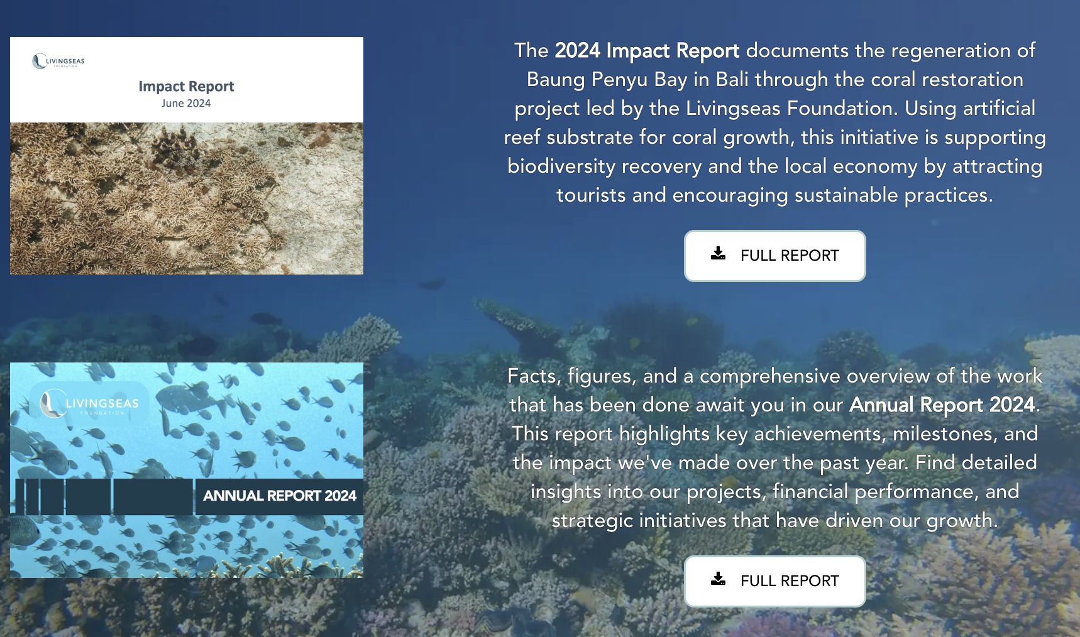
    - Read both reports: https://www.livingseasfoundation.org/impact

- High efficacy but complex scientific approach (focused on survival rates & resilience) by Stanford Researcher Steve Palumbi (Dasu’s connection)
  - Palumbi Lab - look around
  - Some relevant papers:
    - Paper 1: Marine spatial planning to enhance coral adaptive potential
    - Paper 2: Small-scale genetic structure of coral populations in Palau based on whole mitochondrial genomes: Implications for future coral resilience
    - Paper 3: Coral bleaching resistance variation is linked to differential mortality and skeletal growth during recovery

- Existing digital tools relevant to coral restoration:
  - Allen Coral Atlas - powered by ASU, maps the world’s coral reefs and monitors their threats to provide actionable data and a shared understanding of coastal ecosystems.
  - Reefhabilitation - data collection, aggregation, visualization
  - ReefSupport - informal coalition for interested stakeholders
  - CRC - Coral Restoration Consortium
  - Sea Foundry - hardware automation for marine health stakeholders
  - Cordap - collaboration platform to scale tech access
  - Abalobi - software for small fisheries in villages
  - iNaturalist - crowdsourced ecological data
  - Withlocals - ecotourism experiences, some sustainability
  - ReefAdapt

Tab 3
Is this coral even viable?
Who is willing to fund the restoration?
How do we convince people to fund the restoration?
Small money - ecotourism

Does it make sense to grow coral here?
Where is the money for it?
Connect the dots from restoration to money

What is worse for coral; hot water or polluted water? What is it able to defend against better

Contact Vera for potential blue carbon markets.
- They have stuff for mangroves currently but nothing for coral

